CHICKEN BBQ
Sunday, October 25, 2020
11:00 a.m. – 1:00 p.m.

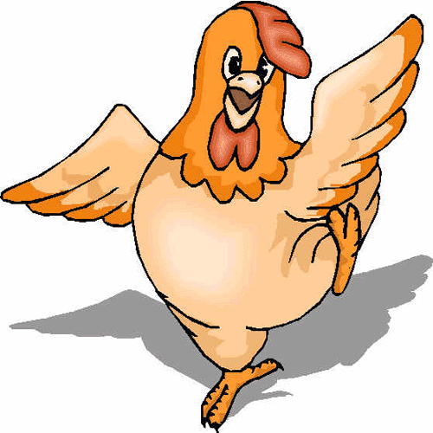

Each dinner will include a half-chicken, baked potato, seasoned corn, and a dinner roll for $10.00.

Dinners will only be available for drive-through pickup outside the Cherry Street entrance. Proceeds will benefit the Major Improvements Fund.

Tickets will be available to purchase in the church office Monday-Thursday 8am-3pm or from any Solomon students. Call 419-849-3600 to reserve your ticket! A limited supply of dinners will be available the day of the BBQ.

Thank you in advance for your support!

