Solomon Lutheran School
Annual Chicken BBQ

Sunday, October 25, 2020
11am-1pm

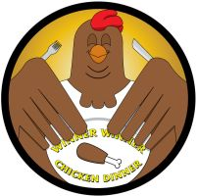

Solomon will be holding our Annual Fall Chicken BBQ on Sunday, October 25, 2020 from
11:00 a.m.-1:00 p.m. Dinners will only be available for drive-through pickup outside the Cherry Street entrance. Each dinner will include a half-chicken, baked potato, corn, and a dinner roll for $10.00. Proceeds will benefit the Major Improvements Fund.

Enclosed are 10 tickets for your family to sell. Any unsold tickets or money for the tickets MUST be returned by Friday, October 9th. Thank you in advance for your help and support!

